Table of Contents
Introduction

Initial Setup
Application User Roles
Configure &General Terminologies
Approval Management
Using ZakCalendar Scheduler Application

Introduction
ZakCalendar Scheduler is the leading calendar app that lets you schedule and manage your events on-the-go. You can create events, define rooms for them, and send meeting requests as well as view, edit, or cancel those requests with just a few clicks.
This app enables you to better manage your time, prepare for upcoming events, track events, and induce flexibility into your schedules. With this app, notifications prior to meetings can be scheduled and meeting notes (including MOM, meeting type etc.) can be collected. It allows an admin to approve or reject the meeting requests, resolve room assignment conflicts, access the meeting details.
With this calendar app, you can:
• select the event to check details, including subject and description
• quickly pre-schedule notifications before the events and used reminders to keep notes
of your meeting details including MOM, meeting type etc.
• schedule multiple meetings on the same date, time, and venue by using different
meeting rooms.
Viewing Preferences: Keep note of your upcoming appointments, meetings and events as per schedule.
Event Management: Instantly create, view, edit, or cancel meeting requests, and as an admin, approve the requests before scheduling a meeting.
Color Coded Customization: Customize the status of your meeting requests with Color Preferences i.e. red for rejected request and green for accepted request.

Initial Setup
- Install the ZakCalendar Scheduler solution in your CRM environment.
- Once installed you will find it under my apps -> Meeting Calendar as shown in screenshot below.
Note: (Installation is done in background, so please check the meeting calendar app in few mins)

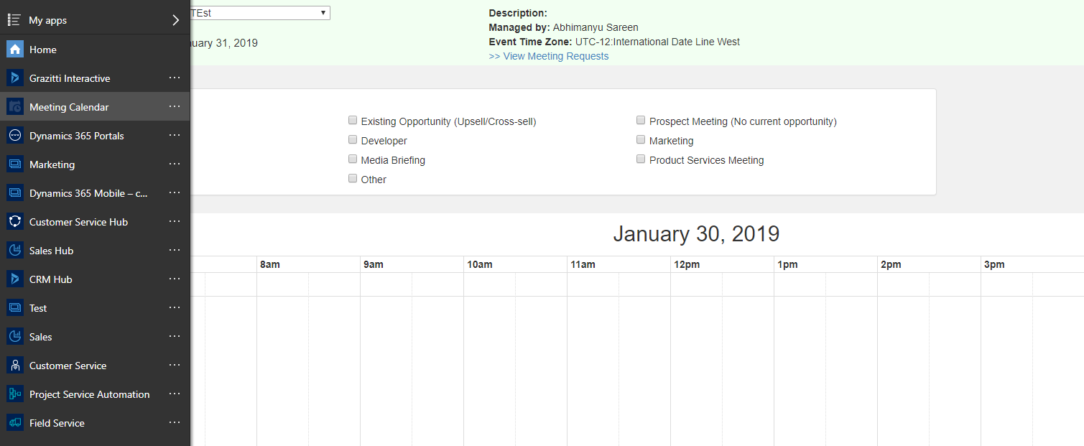

- Next you need to configure the Workflows for sending emails.
- For that, Go to Settings => Solutions => Zak Calendar => Process. As shown in the screenshot below is the list of workflows that you need to activate and add “From Email”.
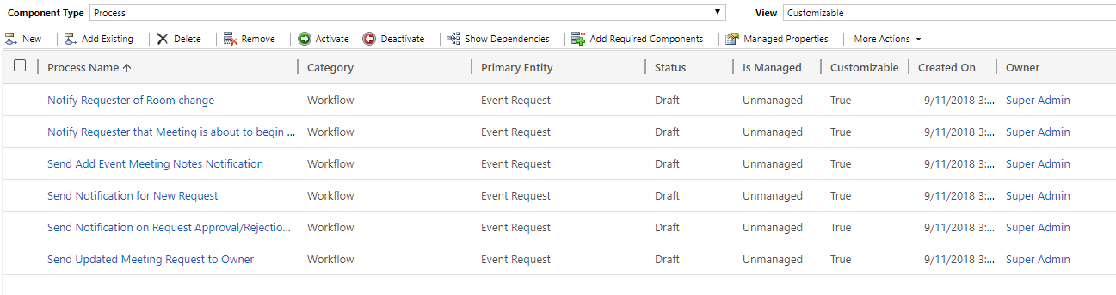
- To update the workflow flow and add email please go to Settings=> Process => Select the workflow.
- Click on “Set Properties” and update “From email” as shown in screen shot.
- Once update is done “Activate the Workflow”.

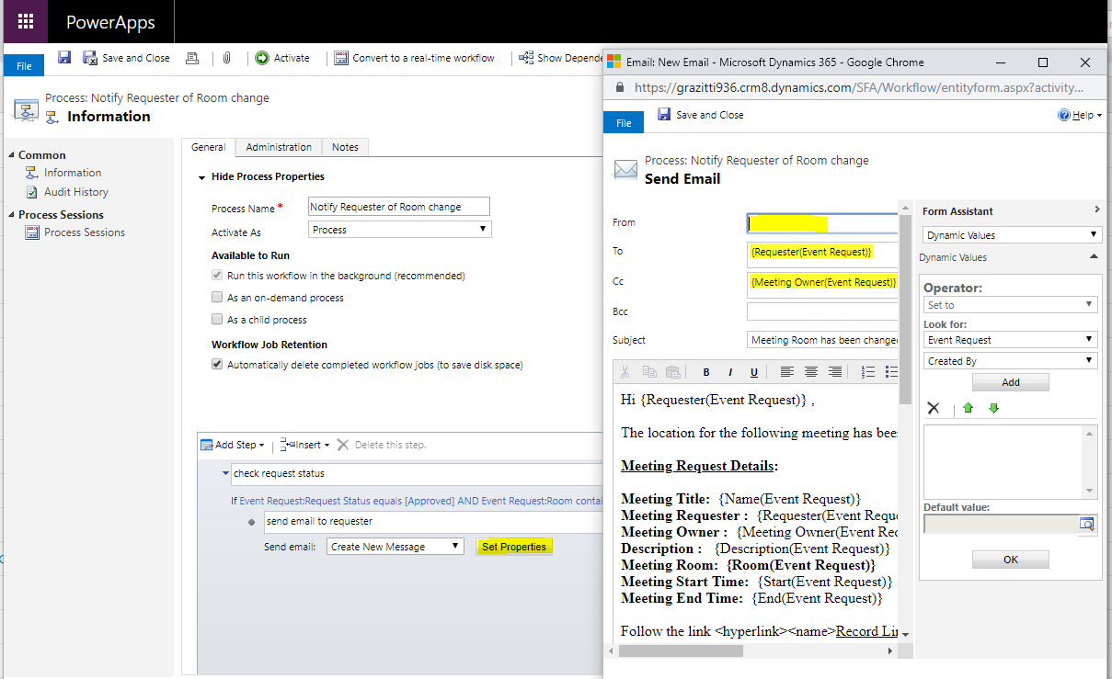

Application User Roles
There are two user roles for this application. Below are the details for them.
Event Managers
These users have full control over all meeting requests in the tool i.e. they can approve/reject or cancel the meeting requests raised by other users
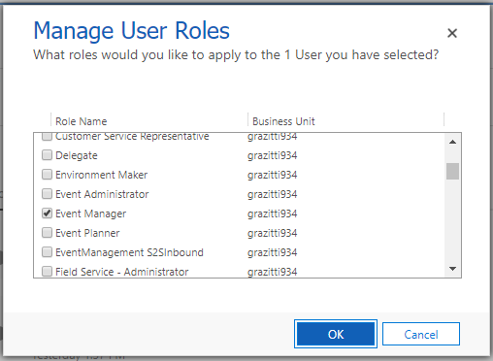

Meeting User/Sales Reps
These are non-admin users. They can only request for new meetings and view/edit their existing meetings’ details. The user who raises the Meeting Request is a Requester and while filling up the meeting form, they add another user to the Meeting know as Meeting Owner (the user who leads the meeting and can also view the meeting data of the Meeting to which they are added as Meeting Owner).
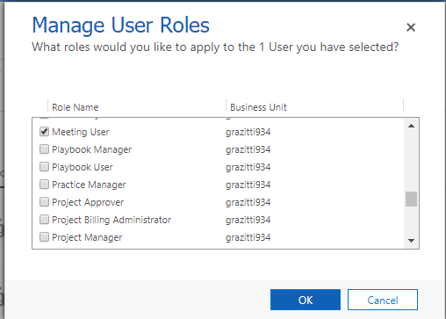

Configure & General Terminologies
To start using your ZakCalendar Scheduler you need to enter the events and room data in the app and then start scheduling the meeting. Below are the details for events and rooms.

What is an event
An event is a planned business occasion in which users from different regions participate and discuss/close business deals. Event has many attributes like Name, Time zone (the Time zone of the region where Event would be taking place), Start Date, End Date, Location, and Description, Banner image of the Event, Notes and Instructions for the use. See the below screenshot for adding the event. (Note: Event time should be between 7:00 AM to 6 PM)
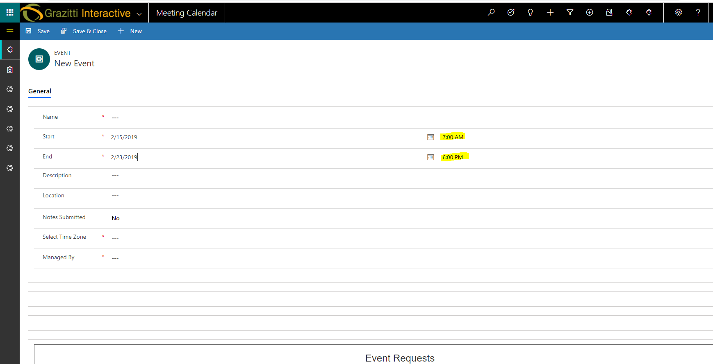

What is a room
Each Event has multiple Rooms associated with it for eg. Dreamforce Event has 20 Rooms.
Room has various attributes such as Name, Booking Start time and End time, Room Unavailability Days (Days of week on which room would be unavailable i.e 1,2,3 etc).
Offsite Room/Chill Zone - If a room is marked as Offsite Room, and users try to book a meeting in that room, the meeting gets booked but is not visible to users. The same time slot can be double booked by the users. These rooms are generally used as chill zone.
Executive Room - These rooms are not visible in the Meeting Tool and are internally used by Event Managers
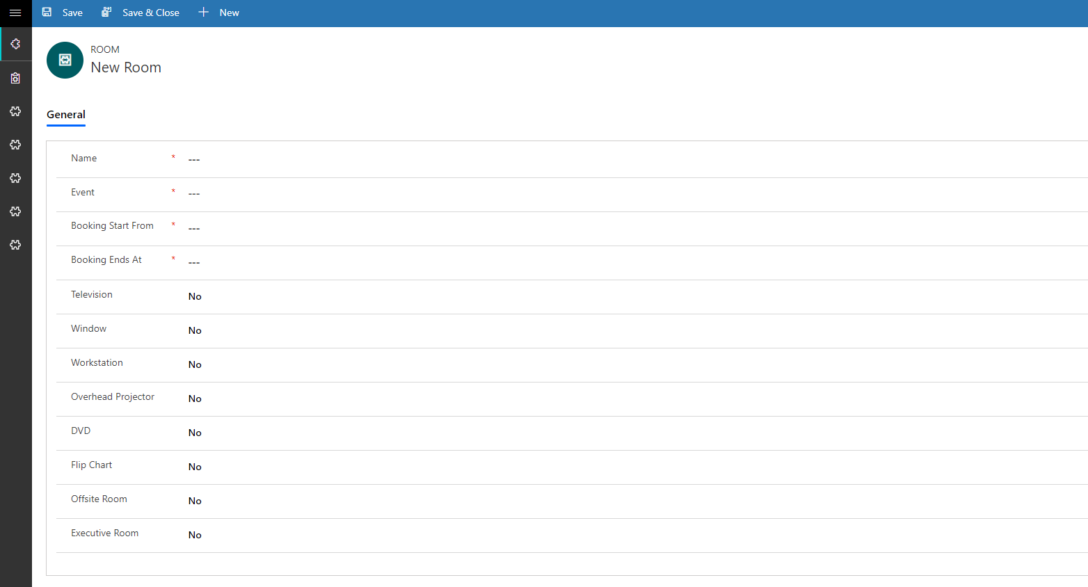

You can also add your Solution Interest data in app as shown in the below screenshot.
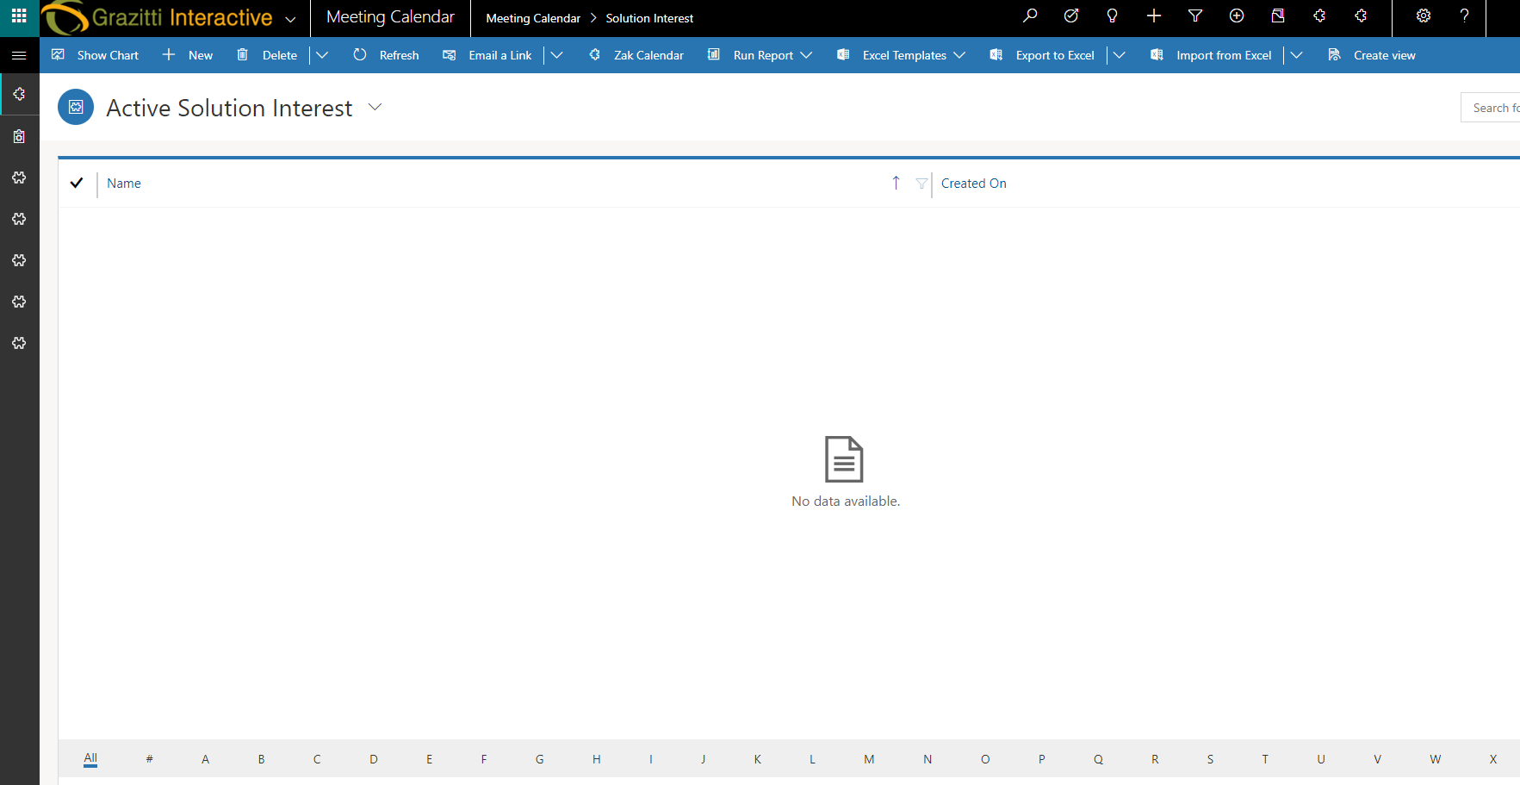

What is a meeting
A meeting is an assembly of two or more persons to discuss business deals. For booking a meeting using the Meeting tool, users need to click in the desired time slot in the calendar and submit the Meeting Request form after filing it.
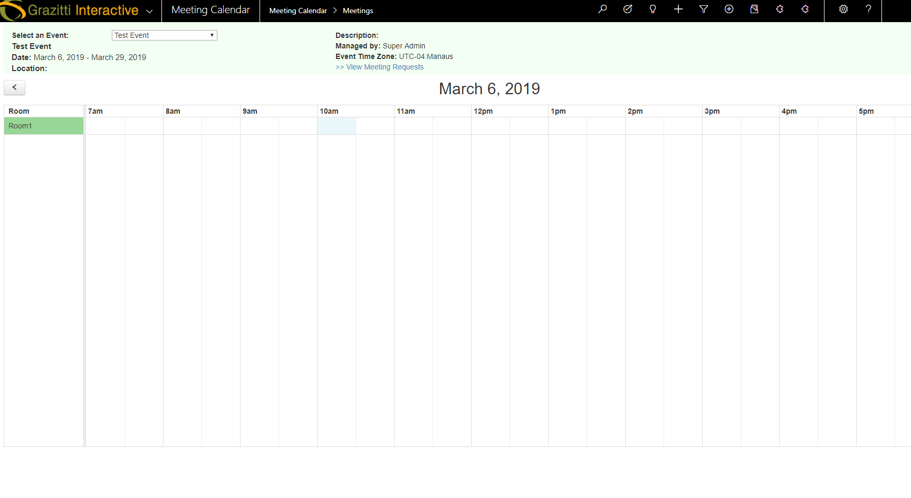

Approval Management
Once the user fills in and submits the Meeting form, a meeting request goes to Event Managers seeking their approval. This functionality is supported by Approval Process at the Backend. Admin can perform three actions on the newly raised request

Approve the request
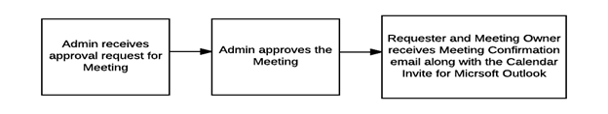

Reject the request Ask Requester to update the Meeting request
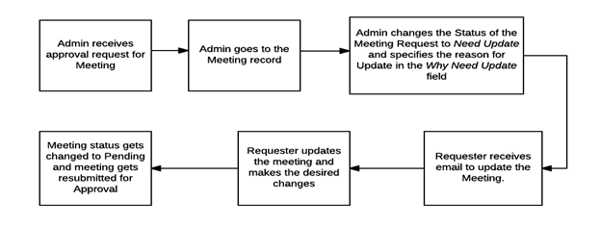

Using the ZakCalendar Scheduler App
Go to the my apps and select “Meeting Calendar”. The app contains the following list:
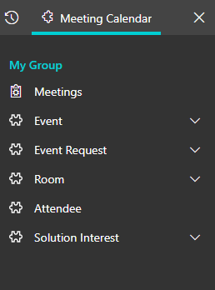
Components of Meeting Scheduler Page:

Header and Statistics
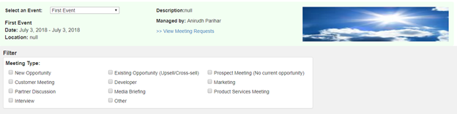
User can view the upcoming events by selecting them from this dropdown. In case they need to access the foregone events, they can use the Events tab

Statistics section (View Meeting Request Link)
It is only visible to Admin users. Only Admin Users can select meetings as per their status.

Filters:
Users can filter events in by using Meeting Type checkboxes -
Only Admin users can view these select boxes. If they select All Events, they can view other users’ events in addition to their meetings.

View Meeting Requests:
Users can use this link to view the meeting requests for the Event on the Standard Detail page of Event. Admin users can view all the meeting requests but Non-Admin users can view only their meeting requests
Calendar Section

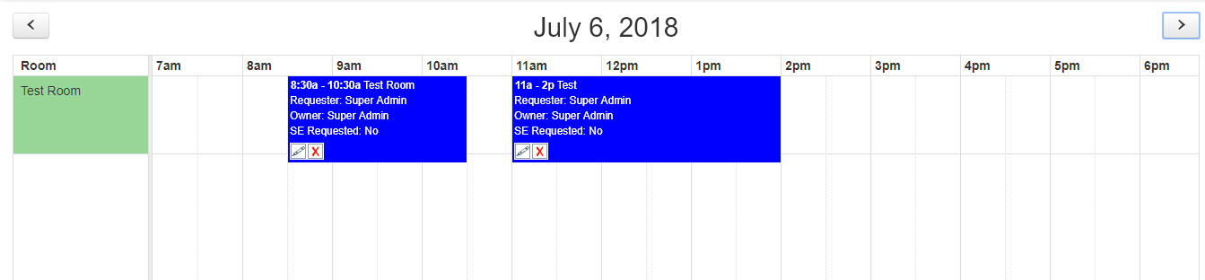
Users can hover over the event request to view its details:

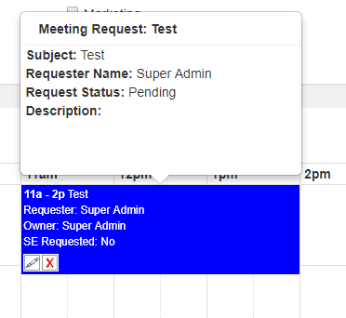
Pencil Icon
Pencil Icon is used to edit the meeting request
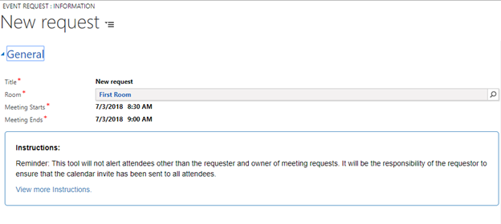
Cross icon
Cross icon is used to cancel the meeting request. On clicking this icon, user views a pop-up seeking confirmation for cancelling the meeting from user. On clicking OK, the meeting gets cancelled
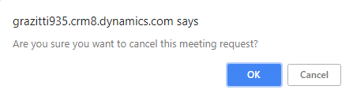
Meeting Colours
Meeting Colours represent the status of the meeting request –
- Green indicates that meeting request has been approved
- Red indicates that meeting request has been rejected
- Blue indicates that meeting request has been sent to the Event Managers for approval i.e. meeting request is still pending for approval
- Yellow indicates that meeting request needs to be updated by the Requester

Meeting Request Form

Meeting form gets opened when the user clicks in a timeslot on the calendar. Meeting form consists of fields that needs to be filled in by the Requester.
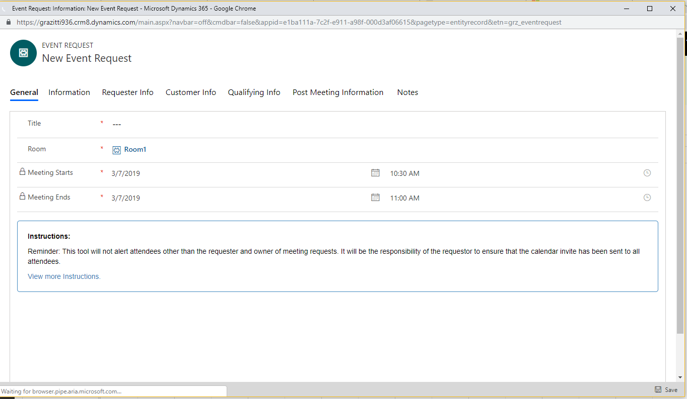

Mandatory fields
Fields marked with are * mandatory fields

Requesting for an Executive
If we select Executive Requested checkbox, then Requested Executive field become mandatory.
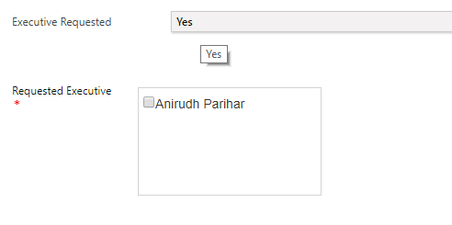

Selecting contacts by choosing a Customer Company
Click on the lookup Icon to choose a customer company
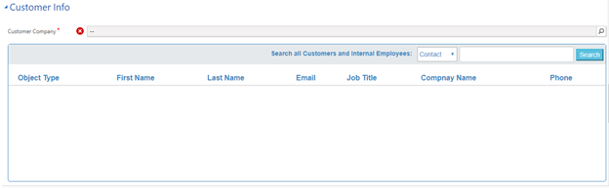

Look-up window opens. Type in the company name and click on Go
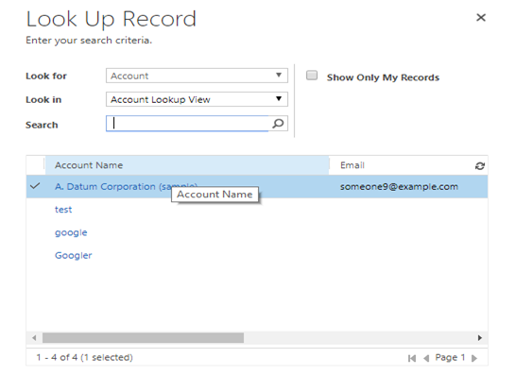
Select the contact that you want to add to the meeting. Selected contacts will get added to the Selected Contacts list.
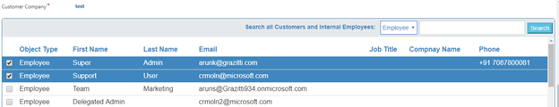
If you want to remove the selected contact, simply uncheck the checkbox from either of the tables

Searching Contacts, Leads and Internal Employees
Select an option to search for Contact, Lead or Employee
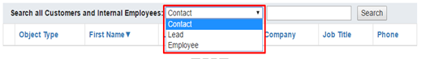

Fill in the name and click on Search
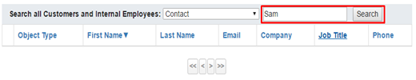
Contacts will appear in the table
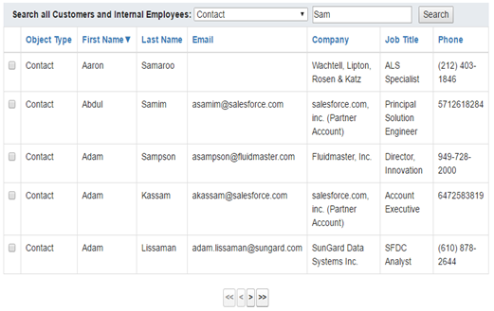
Select the contacts/leads/employees that you want to add to the meeting

ACV Calculation
ACV value is automatically calculated from the Avg ACV field of the Opportunity related to the Meeting Request. Also, the user can manually fill in the ACV (ACV Opportunity) field in the meeting request form

View of other users’ Meetings for Non Admin Users
If slot is booked by any other user than logged in one and currently logged in user is not an admin then show this slot booked but don’t show any meeting information i.e. only coloured slot with no text on it

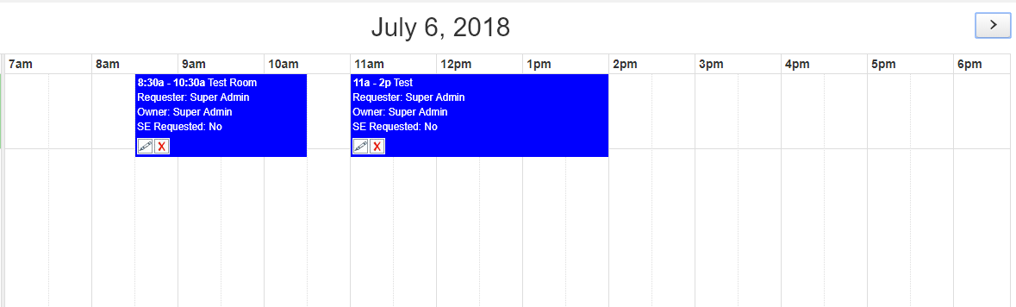

Reminder to add meeting notes post meeting

Immediate Reminder
Reminder is sent to the Requester to adding the meeting notes one hour after the meeting has occurred.

Email Notifications:
Email Notifications go out for the following Events.
Email goes to Event Manager when a user creates a new Meeting Request.

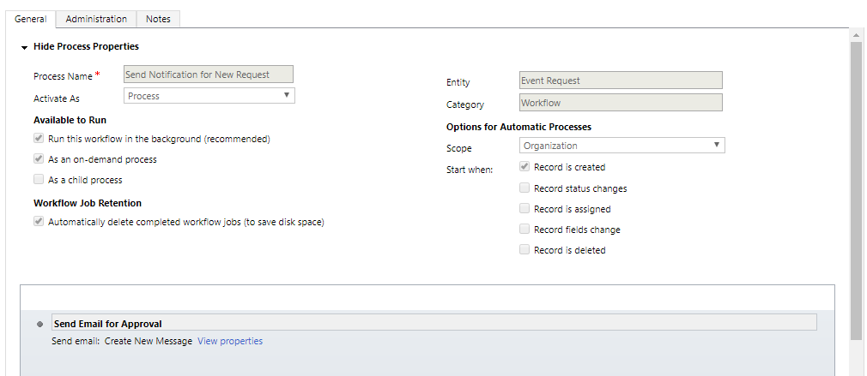
Email goes to Requester and Meeting Owner when Admin approves/rejects/asks Requester to update the Meeting Request.
Email trigger for New Meeting Request:
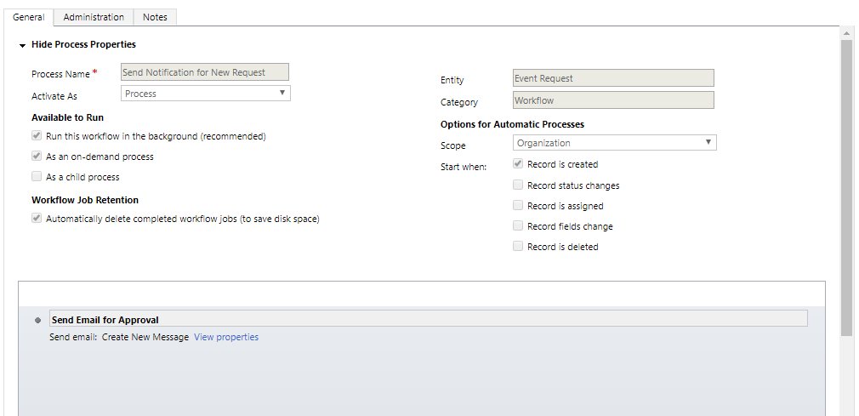

Meeting Approved/Rejection/Update Email Trigger:

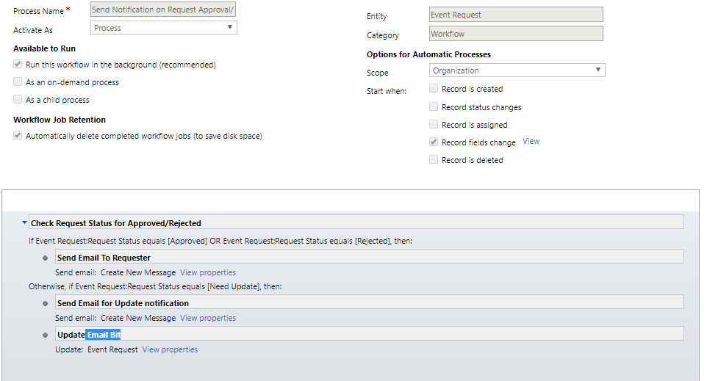

Email Trigger to notify requester for filling Meeting Notes:
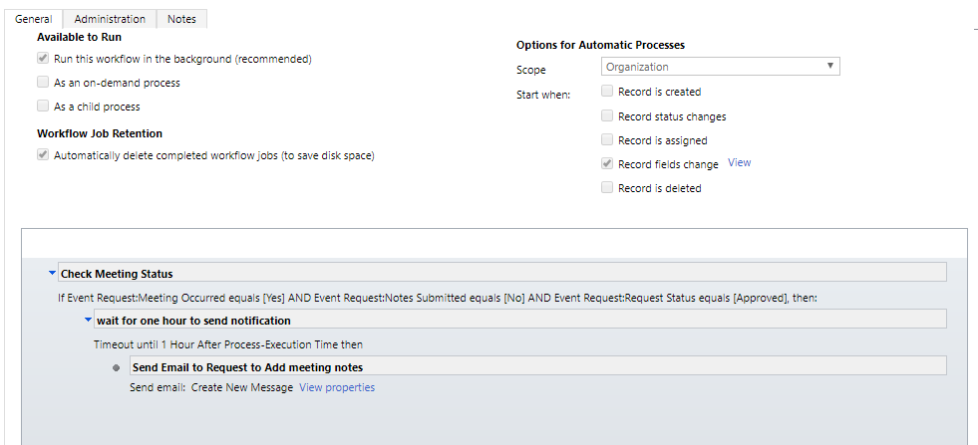

Email Notification to Requester to fill in the Meeting Notes one hour after the meeting has occurred.

Email trigger for room change:
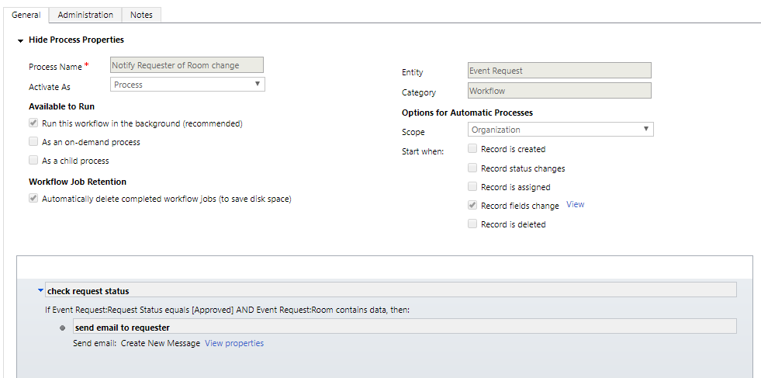

Email Notification to Requester and Meeting Owner in case the Room for any Meeting is changed.

Email trigger for requester about meeting to be begin in 30 Mins

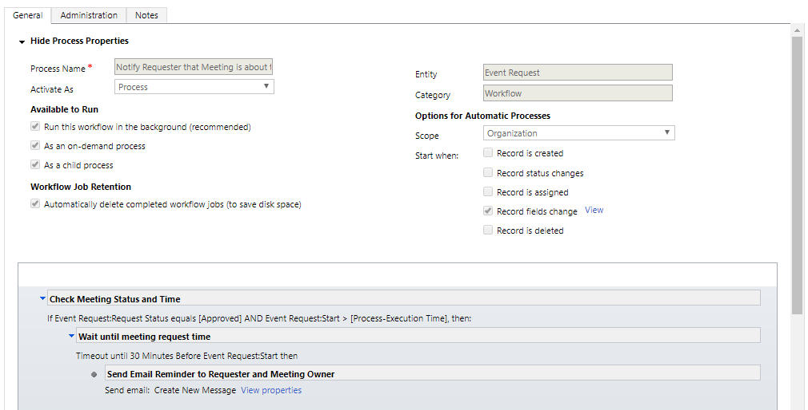

Email trigger for send Updated Meeting Request to Owner:

